Assignment- Mernstack- Bootstrap Basic &Amp; Advanced

# Responsive Web Design with Media Queries:

# Theory Assignment:

Question 1: What are media queries in CSS, and why are they important for responsive design?

**Media queries** in CSS allow you to apply styles based on the characteristics of the user's device, such as screen width, height, orientation, or resolution. They are crucial for creating **responsive designs**, ensuring that a website looks and functions well on different devices (desktops, tablets, smartphones).

# Importance:

1. **Adaptability**: Media queries enable a website to adapt its layout and styling to various screen sizes and devices.
2. **Improved User Experience**: Ensures content is accessible and easy to navigate on any device.
3. **Mobile-First Design**: Allows developers to design for mobile devices first and progressively enhance for larger screens.

# Example:

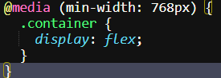

This applies specific styles when the screen width is 768px or more.

Question 2: Write a basic media query that adjusts the font size of a webpage for screens smaller than 600px.

# Basic Media Query for Adjusting Font Size:

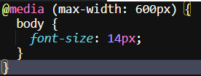

This media query reduces the font size to 14px for screens with a width of 600px or less, enhancing readability on smaller devices.

# Lab Assignment :

• Task: Build a responsive webpage that includes:

• A navigation bar.

• A content section with two columns.

• A footer.

Additional Requirements:

• Use media queries to make the webpage responsive for mobile devices.

• On smaller screens (below 768px), stack the columns vertically.

• Adjust the font sizes and padding to improve readability on mobile.

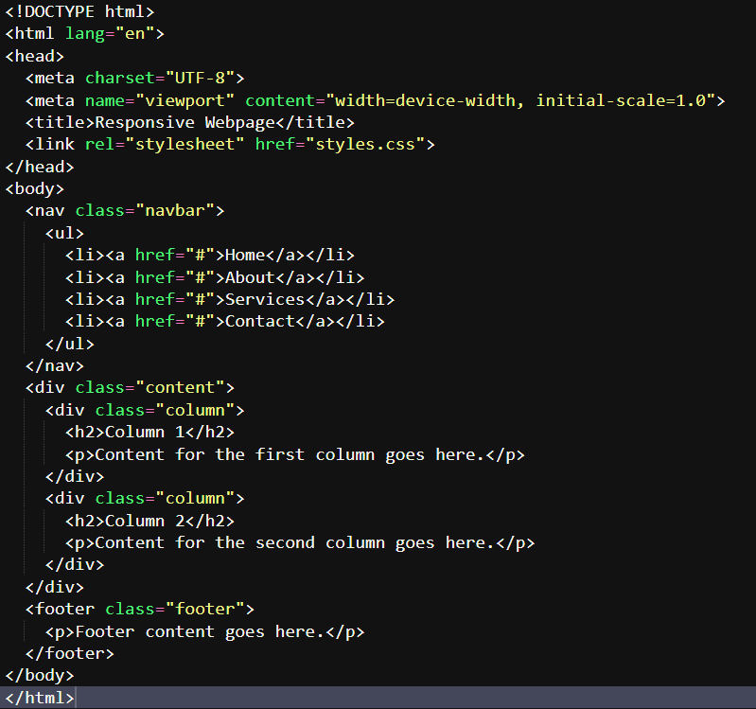

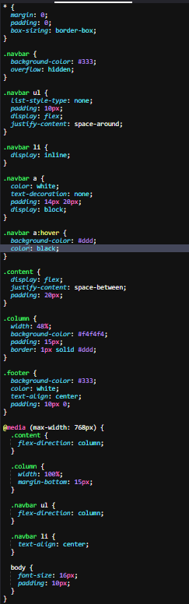

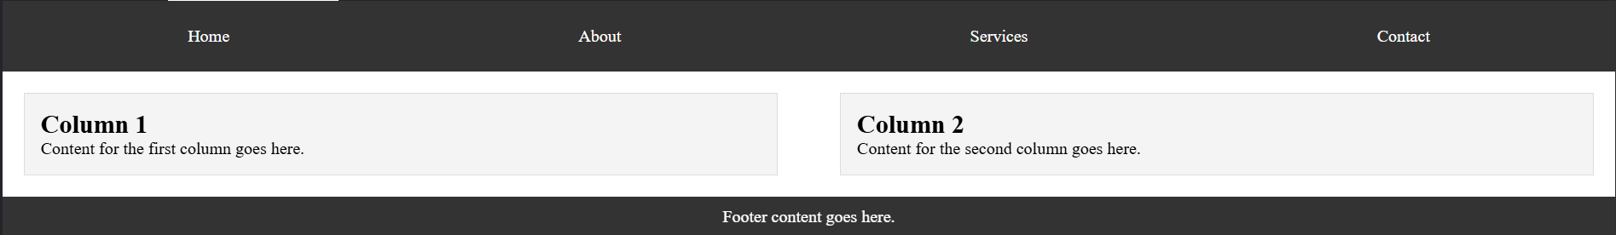

# Typography and Web Fonts:

# Theory Assignment:

Question 1: Explain the difference between web-safe fonts and custom web fonts. Why might you use a web-safe font over a custom font?

**Web-safe fonts** are standard fonts pre-installed on most devices, ensuring consistent appearance across different platforms. Examples include Arial, Times New Roman, and Courier New.

**Custom web fonts** are fonts not pre-installed on devices. They are loaded from external sources (like Google Fonts) and offer greater design flexibility and uniqueness.

# Differences:

1. **Compatibility**: Web-safe fonts are universally supported, ensuring consistent display. Custom fonts might not render properly if not loaded correctly.
2. **Performance**: Web-safe fonts load faster since they're already on the user's device. Custom fonts can slow down page load times as they require additional resources.

# Why Use Web-Safe Fonts:

* **Reliability**: Guaranteed to work across all browsers and devices.
* **Performance**: Faster loading times, improving user experience, especially on slower connections.
* **Fallback**: As a fallback option when custom fonts fail to load, ensuring readability.

Web-safe fonts are a safer choice for performance and compatibility, while custom fonts offer more unique design options.

Question 2: What is the font-family property in CSS? How do you apply a custom Google Font to a webpage?

**font-family** is a CSS property used to specify the font of text. It defines a prioritized list of font names and fallback options to ensure text displays properly if the preferred font is unavailable.

# Applying a Custom Google Font:

**1.Import the Font**:

* Use the <link> tag in the <head> section of your HTML to import the font



**2.Apply the Font in CSS**:

* Use the font-family property to apply the imported font.



# Example:

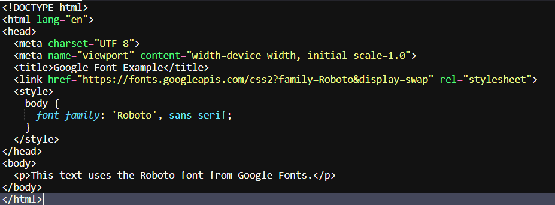

**font-family** ensures the correct font is used, and importing Google Fonts adds a custom style to the webpage.

# Lab Assignment:

Task: Create a blog post layout with the following:

• A title, subtitle, and body content.

• Use at least two different fonts (one for headings, one for body content).

• Style the text to be responsive and easy to read.

Additional Requirements:

• Use a custom font from Google Fonts.

• Adjust line-height, font-size, and spacing for improved readability.

